Registration Form
(One Per Child)

Fee: $50 (VBS), pay to : WCEC
$100, pay to: Soojin Suh

Fee: $75
P

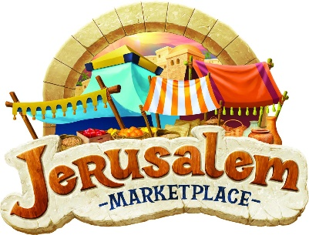

Child’s name: _______________________________________________________
Last school grade completed: __________________________________________
Name of parent: ____________________________________________________
Best phone numbers to contact:________________________________________
Street address: ______________________________________________________
City: _________________________________ State: ________ ZIP: ____________
Email address: ______________________________________________________
Home Church: ______________________________________________________

Allergies or other medical conditions: ____________________________________________________________________
In case of emergency, contact name: _____________________________________
Phone: ______________________________ Relationship to child: ______________

Korean Classes: YES or NO (1:00pm-2:30pm) --- $100
T-Shirt size: Youth --- Small Medium Large
Adult --- Small Medium Large

Turn to pg. 2 , please!
Release of Liability
I hereby release WCEC and VBS volunteers, from any and all liability for damage to or loss of personal property, sickness or injury while participating in the Event activities.
I hereby state that my child is in sufficient physical condition to accept all Event activities. I understand that participation in this program is strictly voluntary and I freely chose to participate.
I understand that WCEC doesn’t provide medical coverage for me. I verify that I will be responsible for any medical costs my child may incur as a result of participation.
I give permission for WCEC to photograph & making video my child(ren) for promotional & internal use.

Parent signature: ___________________________ Date:________________

Mail to:
Jerusalem Marketplace VBS
1512 Brackenville Rd.
Hockessin, DE 19707

Email to: wcec.chinglie@gmail.com

For Church use only: Check # ______________ Cash $ _________________

